R. Reports Menu: 5. Invoice Maintenance

Table of Contents
Invoice Maintenance 2
The “Invoice” tab 3
The “Billing Codes” tab 4
The “Misc Fields” tab 5

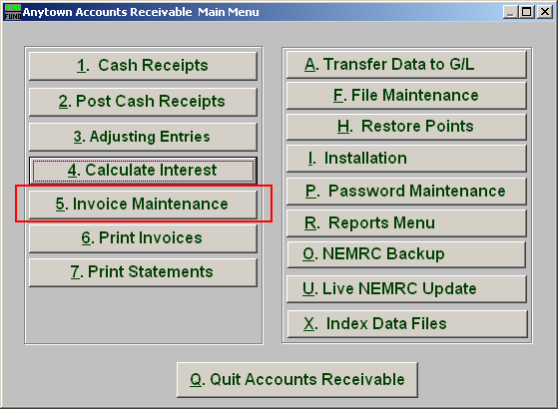
Click on “5. Invoice Maintenance” from the Main Menu and the following window will appear:

Invoice Maintenance

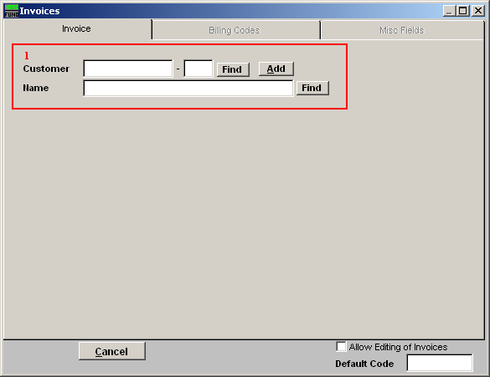
- Type in the Customer ID OR Name OR click the “Find” button to select from the Lookup window OR click on “Add” to add a new Customer. When adding a new customer refer to the “File Maintenance” (under the “Customer File” section) for instructions.

The “Invoice” tab

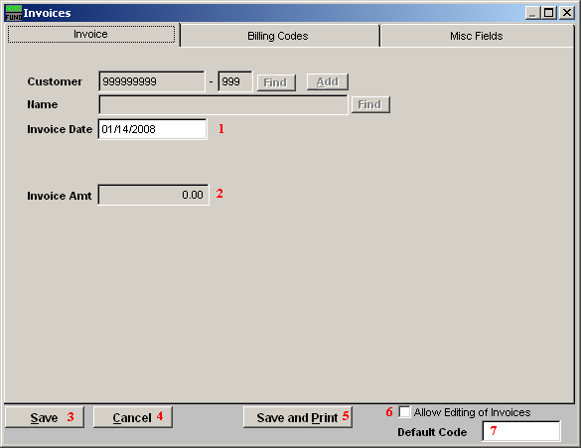
- Invoice Date: Enter the date of the invoice.

- Invoice Amt: Enter the amount of the invoice. You now need to click on the Billing Codes Tab and follow the instructions below.

- Save: Click “Save” to save changes and return to the previous screen.

- Cancel: Click “Cancel” to cancel and return to the previous screen.

- Save and Print: Click this button to Save changes and Print a report of the changes.

- Allow Editing of Invoice: Invoices cannot be edited unless this option is checked off.

- Default Code: Enter a code that you wish all new invoices to default to. This makes creating several invoices for the same code much easier.

The “Billing Codes” tab

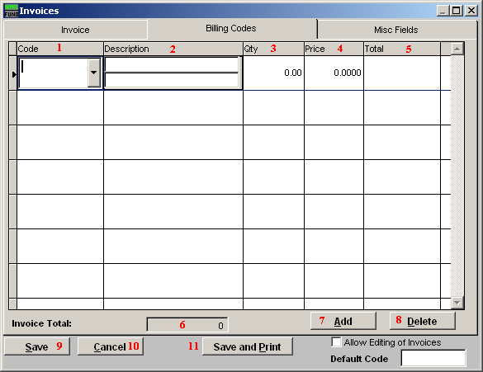

- Code: Enter the Code or use the drop down arrow and select from there. Codes are defined in the “File Maintenance – Code Maintenance” document.

- Description: Enter a Description of the Code. This is two lines of 40 characters.

- Qty: Enter the Quantity of the item.

- Price: Enter the Unit Price of the line item.

- Total: This field will automatically be filled in.

- Invoice Total: This field will automatically be filled in.

- Add: Click this button to add a new code.

- Delete: Click on a line to select then click this button to delete the selected code.

- Save: Click “Save” to save changes and return to the previous screen.

- Cancel: Click “Cancel” to cancel and return to the previous screen.

- Save and Print: Click this button to Save changes and Print the invoice.

The “Misc Fields” tab

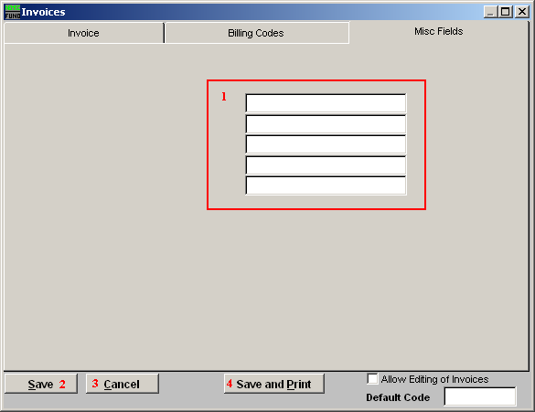
- Misc Fields: Type in any extra information here. These fields are defined on “I. Installation.”

- Save: Click “Save” to save changes and return to the previous screen.

- Cancel: Click “Cancel” to cancel and return to the previous screen.

- Save and Print: Click this button to Save changes and Print the invoice.

